PFYT Planner

Client Website Overview Guide

www.**plan**foryourtomorrow.com

300 E. Broad Street, Suite 530

Columbus, OH 43215



855-332-1533614-567-2520www.planforyourtomorrow.comtom@planforyourtomorrow.com

facebook.com/planforyourtomorrow

Securities and Retirement Plan Consulting Program advisory services offered through LPL Financial,a Registered Investment Advisor, Member FINRA/SIPC. Other Advisory Services offered through Stratos Wealth Partners, Ltd, a Registered Investment Advisor. Plan For Your Tomorrow, Inc. and Stratos Wealth Partners, Ltd. are separate entities from LPL Financial.

This training guide will provide an overview of the Client Website. The Client Website is a Personal Financial Website that will provide you with a consolidated view of your financial information.

There are many features such as the **Organizer**, **Workshops**, **Budgeting**, **Reports**, and the **Vault** (an online safe deposit box to store digital copies of valuable personal documents such as wills, trusts, passport information, photos, etc.).

Note – 3 security questions will need to be established the first time you logon. Each subsequent logon will prompt for an answer to 1 of the 3 selected security questions unless this box is checked:

1. At the bottom right hand side of the **Home** page, click the **Get Started** link under **Tour Guide** for help navigating the site. 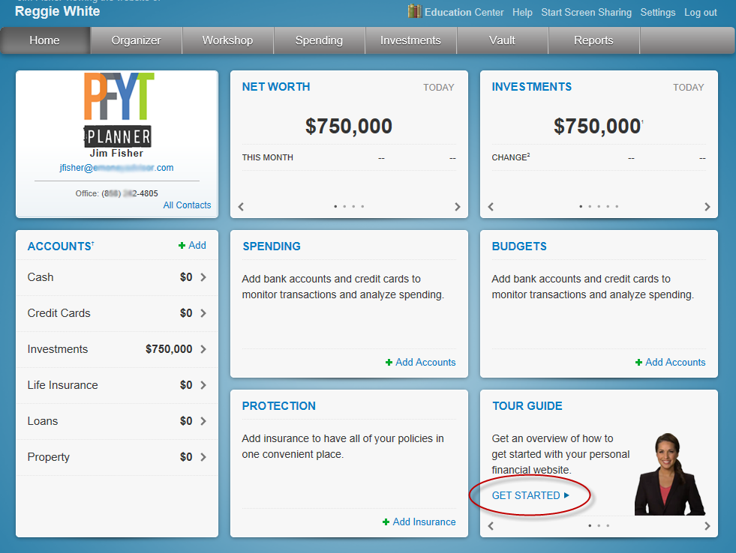
2. Click **Settings** to set alerts, security & privacy settings.

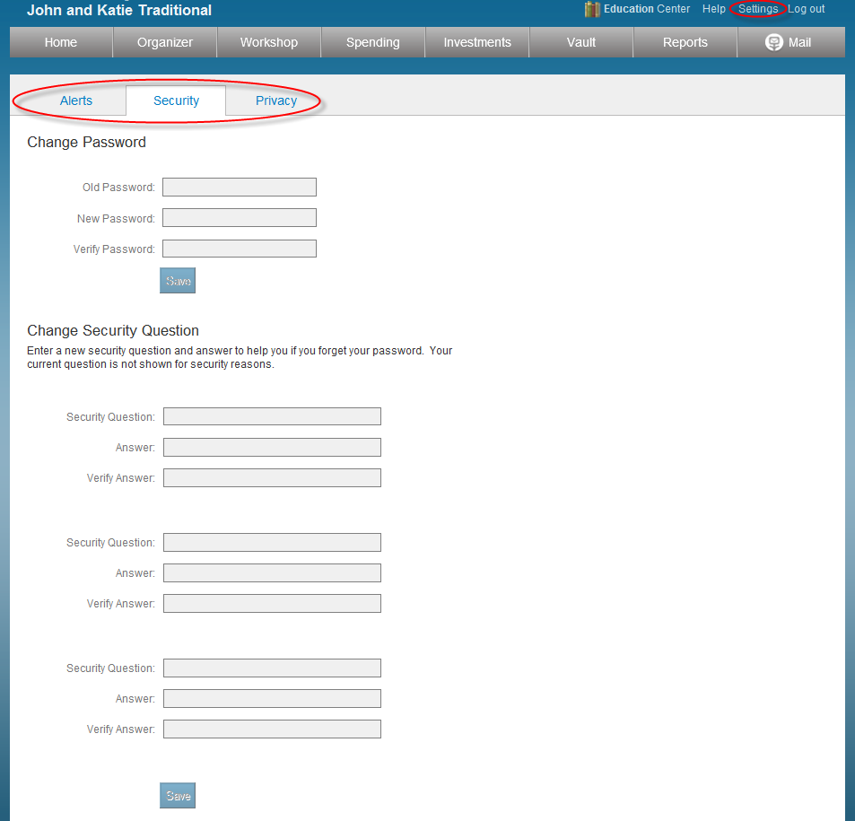

Note: See supplement titled Client Site Alerts for information on configuring the client alerts.

1. The **Privacy** tab allows control of the Advisor’s access.

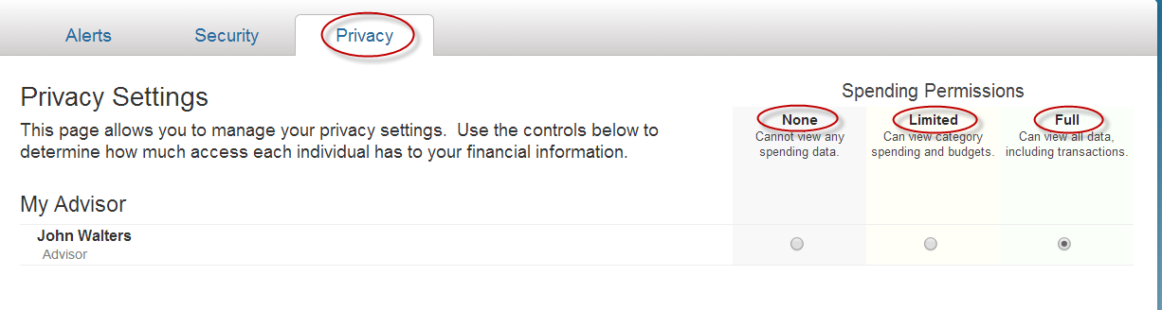

**None -** the Advisor will not have access to any spending data.

**Limited** - he Advisor will have limited access to spending details and can view only the categories regarding the spending and budget, NOT individual transactions.

**Full access** - the Advisor can view spending and budgeting items, INCLUDING transactions.

1. The **Organizer** is a place to enter your data, provided that your Advisor has enabled this feature.

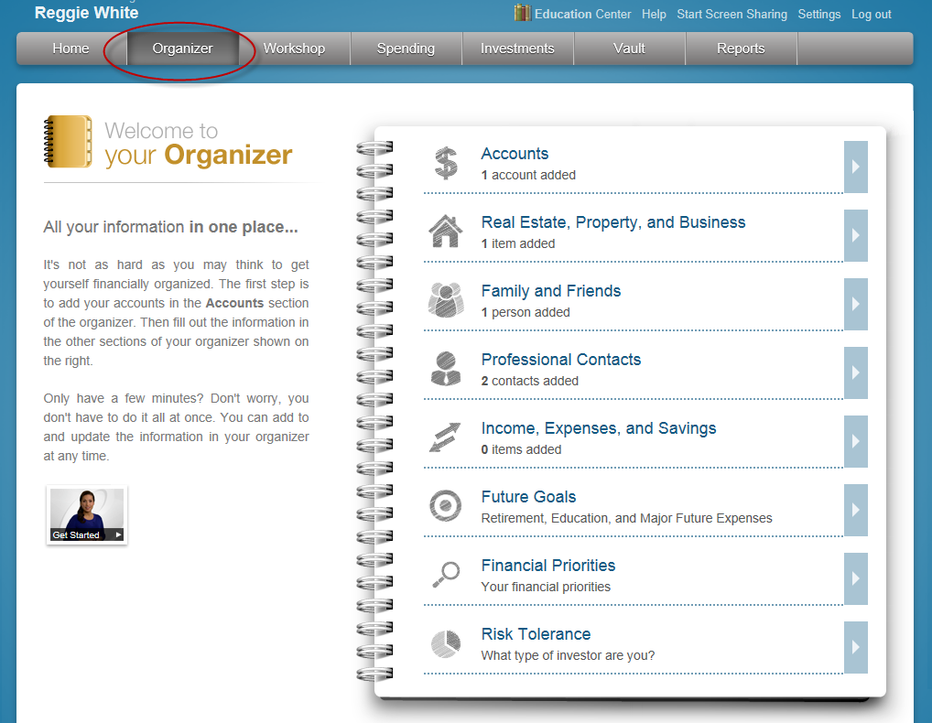

1. To add accounts to the **Organizer**, click **Accounts**.

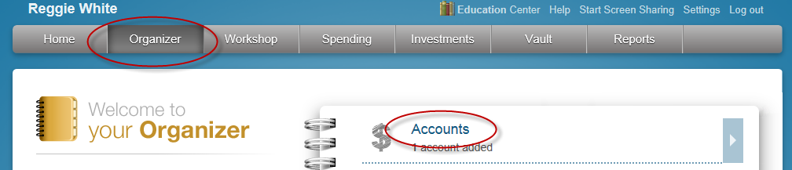

1. Click the **Add** button to search for a specific institution.

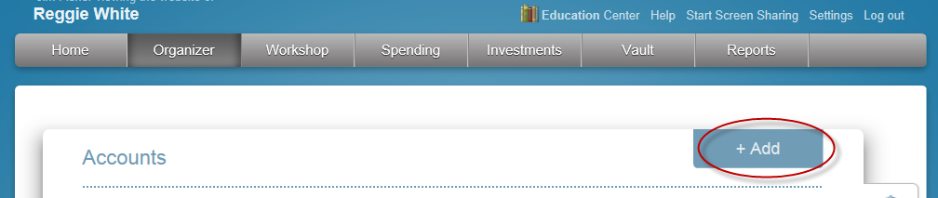

1. Type in the name of the institution where you have accounts and click **Search**.

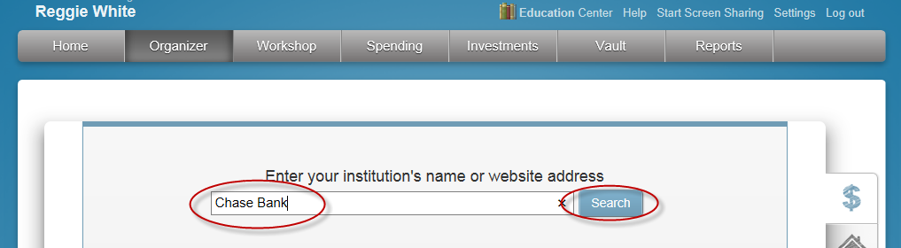

Note – There must be an online account set up at the institution in order to connect it and bring the current value into the **Organizer**.Formore information on connecting accounts, see the **Client Site - Connections Booklet**.

1. To **manually** enter data, select from the appropriate categories.

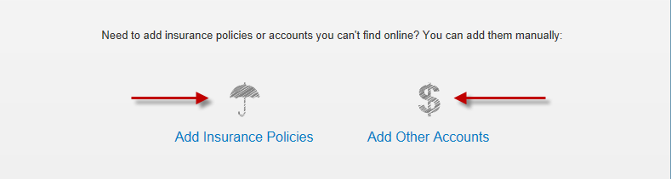

1. The **Workshop** tab provides a quick analysis to determine if you are saving enough for retirement or a college expense. You can also quickly analyze your life insurance needs, see if your investments are properly allocated and check to see if your personal finances are balanced. Follow the tour guide to go through these exercises.

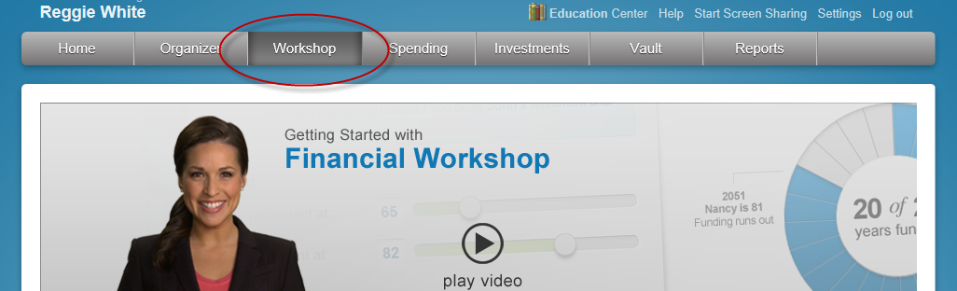

1. The **Spending** tab allows you to track your spending habits and build a custom budget.
2. The **Overview** tab provides a pie chart based off of recent transactions imported from aggregated accounts.
3. The **Budget** window is a snapshot that allows you to monitor if you are on track with your monthly budget.
4. The **Transaction** tab is where to view transactions pulled in from connected accounts.

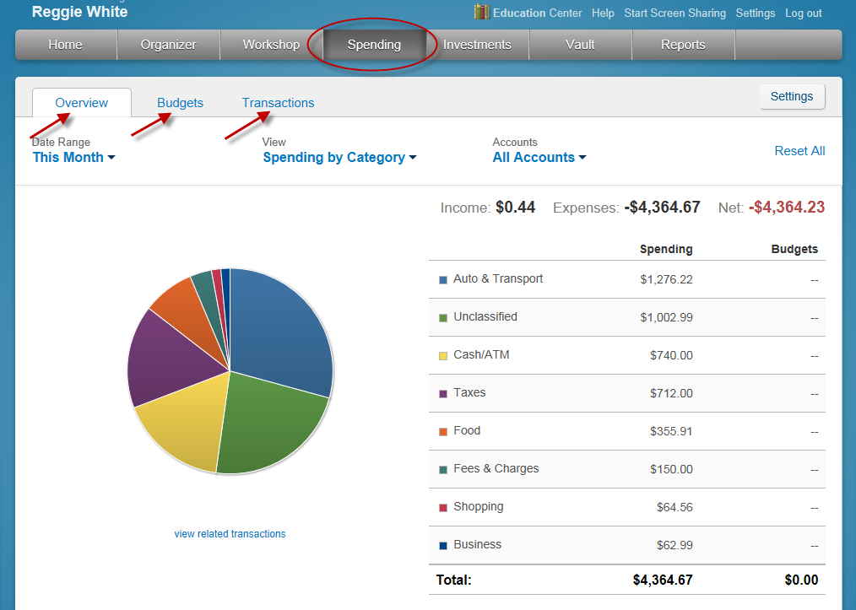

Note: For detailed information on how the budgeting & transaction features work, please refer to the **Client Site Budgeting for Clients** user guide.

1. The **Investments** tab allows you to view up to date market information based off of any connected investments.

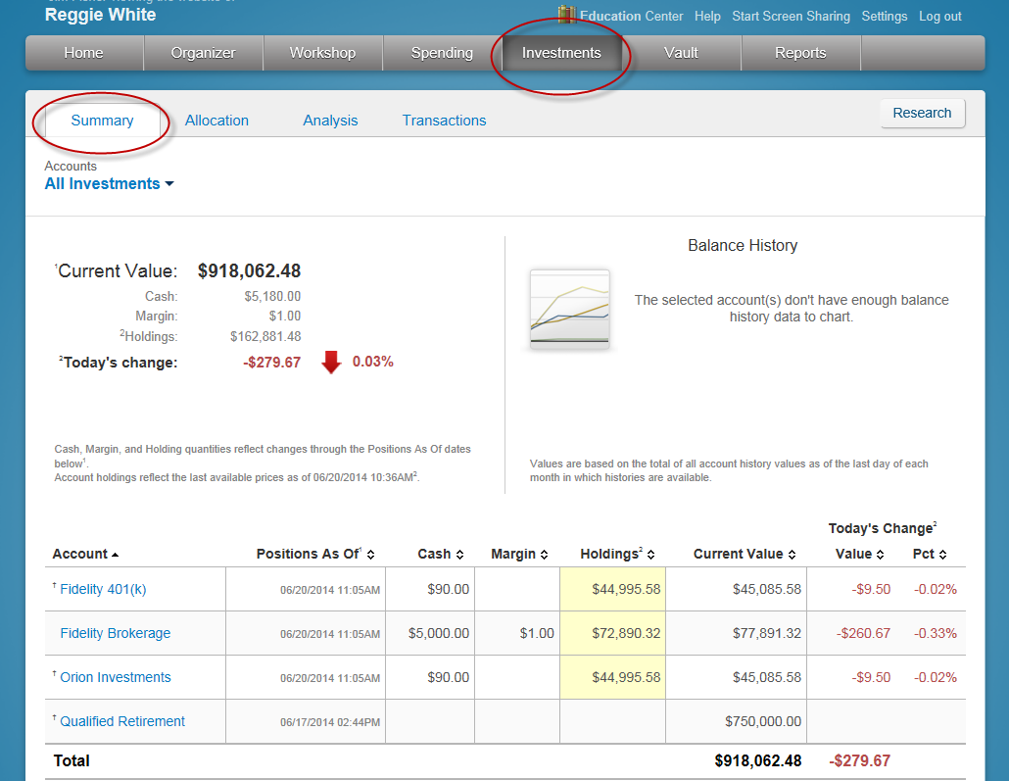

1. Click on the **Account Name** to see a holdings break down of a given account.

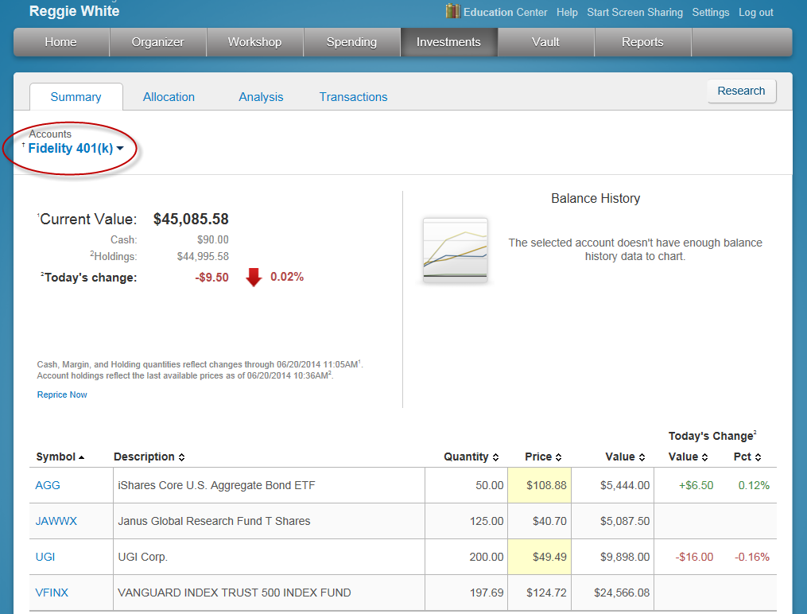

1. The **Vault** provides secure storage for valuable personal documents (**wills, trusts, insurance documents, passports, etc.**) in electronic format.
   1. You can upload documents into the **Shared Documents** folder, allowing the Advisor to also view the contents.
   2. You can upload documents into the **My Documents** folder, which is a private folder where only you can access the contents.

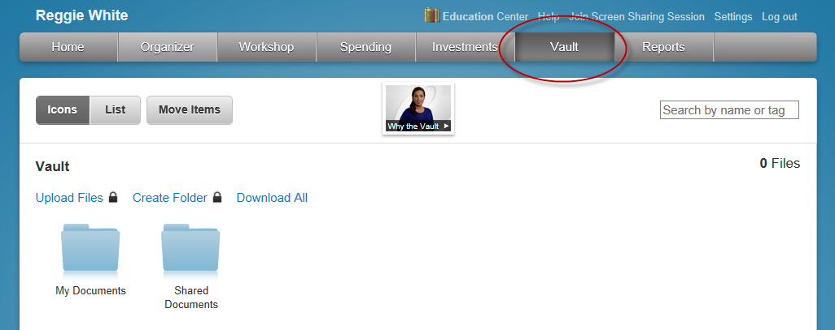

Note: The Vault allows storage files of the following types: aifc, aiff, aif, au, avi, bmp, doc, gif, jpg, jpeg, mov, mp3, mpeg, mpg, pdf, png, ppt, ps, rtf, snd, swf, tax, tif, tiff, txt, wav, wma, wmv, wps, xls, and xml.

1. The **Reports** tab provides a series of statements about your financial situation. To view a report, simply choose from the drop down list located under Report Selection.

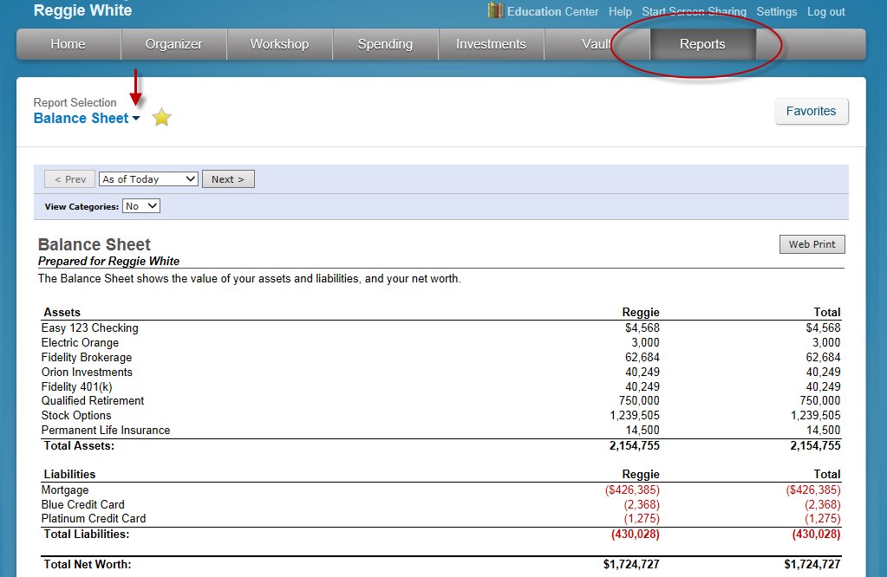

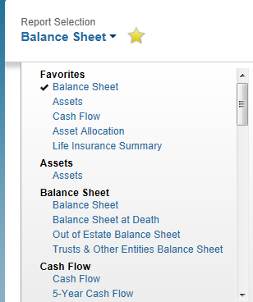

1. The Awards tab is a free service that allows you to track Frequent Flyer miles, Hotel Award points, Credit Card Awards, and other points programs.
2. By signing up for access you can track your awards on the web. You can also receive statements & alerts via-email.
3. To enroll, go to the Home page and scroll through the tiles at the bottom right side of page until you see **AWARDS. Click GO TO AWARDS.**

